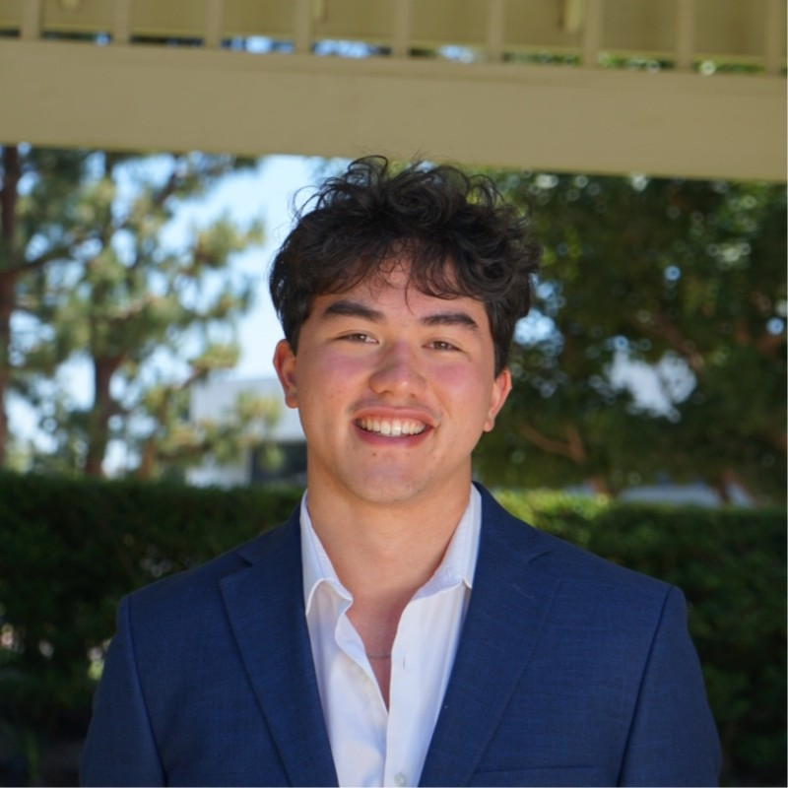
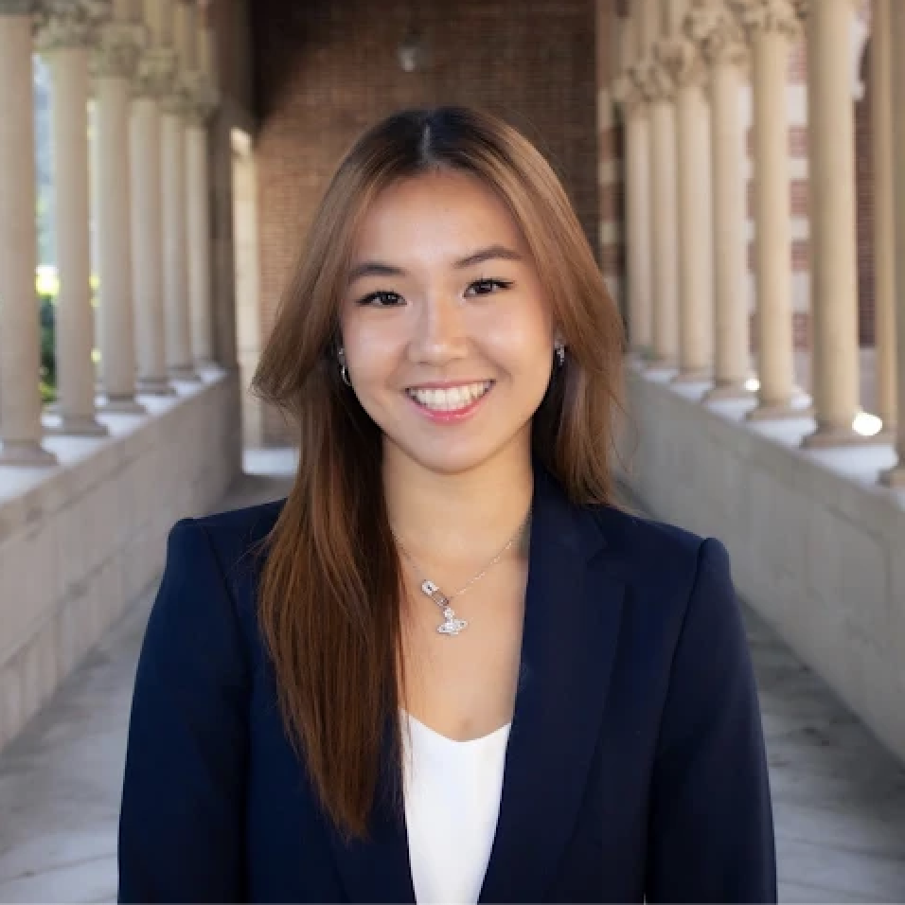
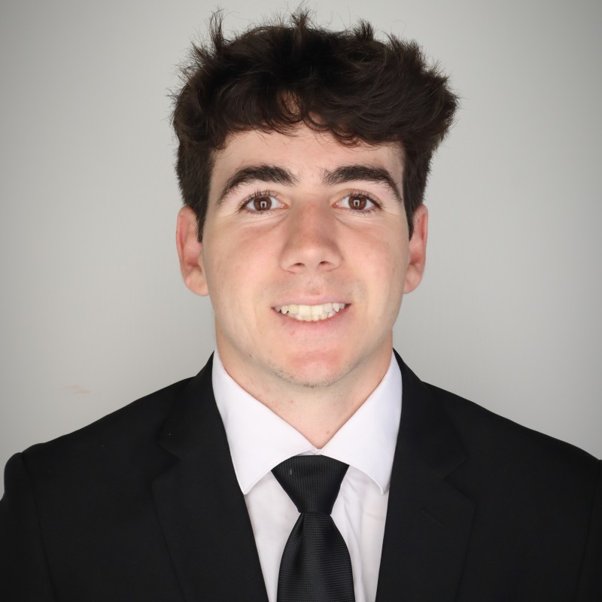
We are a multidisciplinary research team at the University of Southern California partnering with Professor Sriram Dasu to study how coral reef restoration can be more effectively valued, funded, and strategically prioritized. Our work focuses on understanding how ecological outcomes translate into economic, social, and risk-reduction value, and how these values are perceived by different stakeholders.
JUSTIN SHIH
B.S. | Artificial Intelligence for Business
Hometown: Oregon, USA
Experience: Social Impact Consulting, Non-Profit Tech
Strategy, Machine Learning Engineering
CONNOR HUGHES
B.S. | Business Administration - Finance
Hometown: New Jersey, USA
Experience: Non-Profit Management, Financial Forecasting
& Analysis, Fundraising Strategy
YOLANDA ZHANG
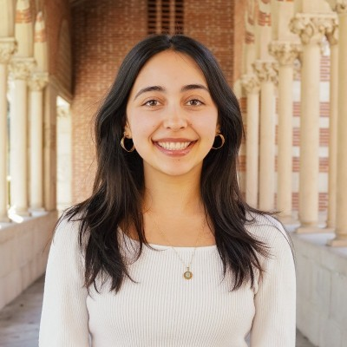
B.S. | Business Administration - AI, Cinematic Arts
Hometown: Vancouver, CA
Experience: Corporate Finance & Strategy, Social Impact Consulting, Startup Product Management
MARINA PARKER
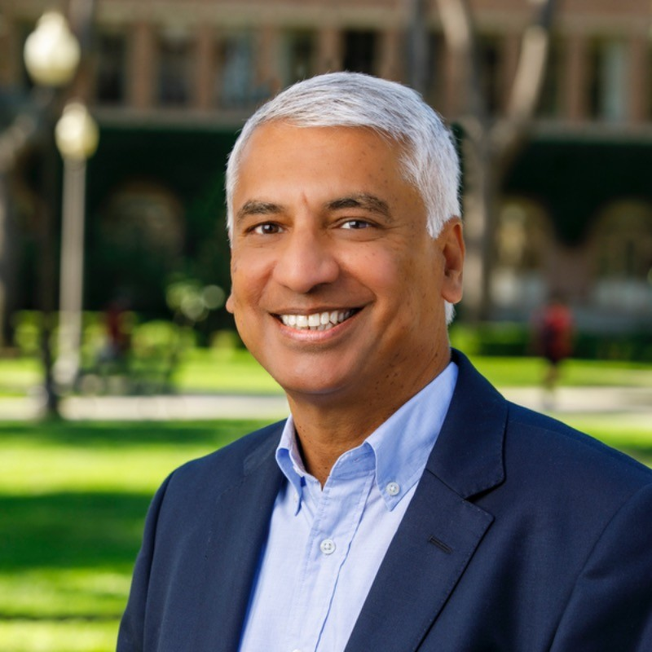
B.S. | Business Administration - Finance
M.S. | Environmental Data Science
Hometown: California, USA
Experience: Social Impact Consulting, Marketing Strategy, Entrepreneurship, Startup Consulting

SRIRAM DASU, PhD
PhD | Operations Management
USC Professor: Data Science; Business of Sustainability; Supply Chain Management; Machine Learning
Specialties: Healthcare Management, Customer Experience, Design of Service Systems, Supply Chain Management

